Department of Software Engineering
Mehran University of Engineering and Technology, Jamshoro

Course: SWE324 - Data Warehousing and Data Mining
Instructor | Rabeea Jaffari | Practical/Lab No. | 03
Date | 16 April 2019 | CLOs | CLO-4: P3 & P4
Signature |  | Assessment Score | 1 Mark

Topic | To familiar with OLTP system query execution
Objectives | To learn query execution in OLTP databases

Lab Discussion: Theoretical concepts and Procedural steps

CLASS TASKS:
- Write An SQL Query To Fetch “FIRST_NAME” From Worker Table In Upper Case.

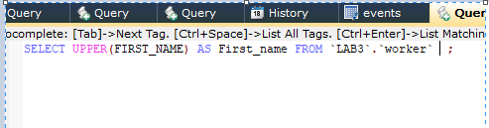
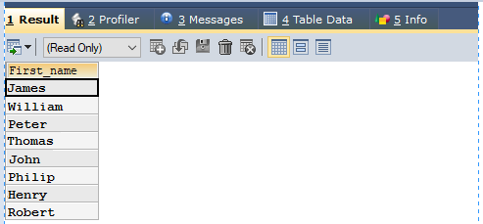
- Write An SQL Query To Fetch Unique Values Of DEPARTMENT From Worker Table.
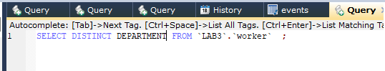
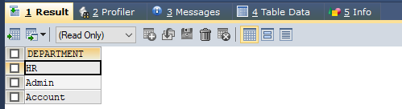
- Write An SQL Query To Print Last Three Characters Of FIRST_NAME From Worker Table.
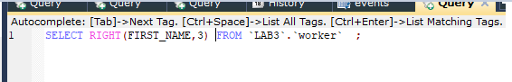
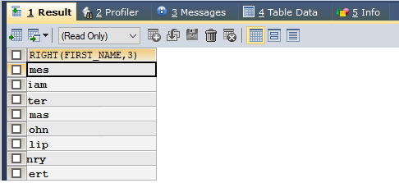

- Write An SQL Query To Print The FIRST_NAME From Worker Table After Removing White Spaces From The Left Side.
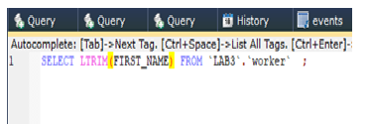
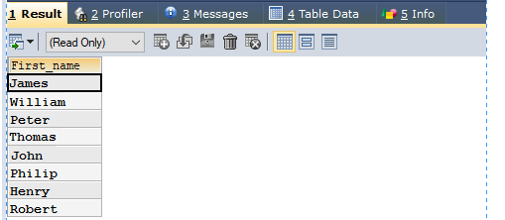

- Write An SQL Query To Print The FIRST_NAME From Worker Table After Replacing ‘a’ With ‘A’.
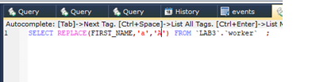
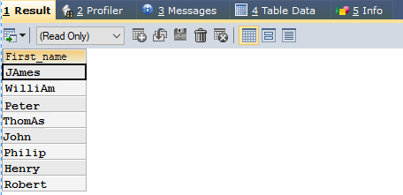

- Write An SQL Query To Print All Worker Details From The Worker Table Order By FIRST_NAME Descending.
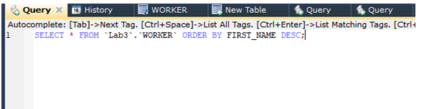
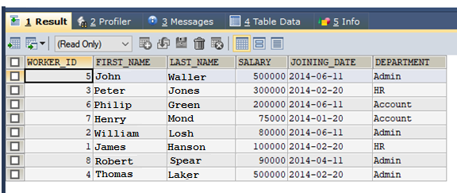

- Write An SQL Query To Print Details For Workers With The First Name As “John” And “Peter” From Worker Table.

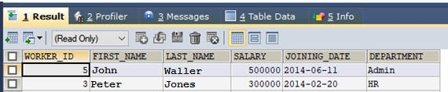

- Write An SQL Query To Print Details Of Workers With DEPARTMENT Name As “Admin”.
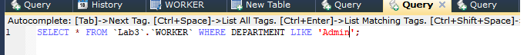
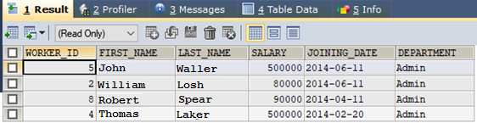

- Write An SQL Query To Print Details Of The Workers Whose SALARY Lies Between 100000 And 500000.
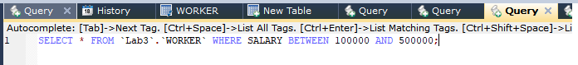
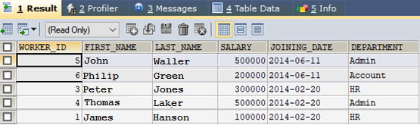

- Write An SQL Query To Print Details Of The Workers Who Have Joined In Jan’2014.
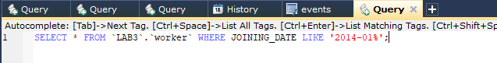
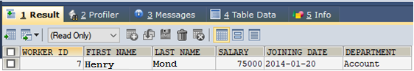

- Write An SQL Query To Fetch The Count Of Employees Working In The Department ‘Admin’.
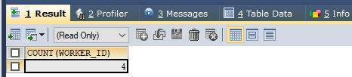

- Write An SQL Query To Fetch The No. Of Workers For Each Department In The Ascending Order.
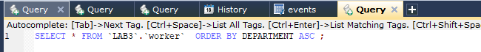
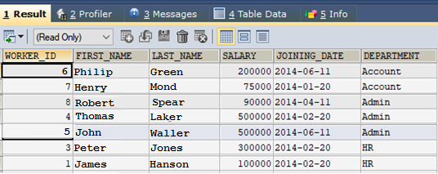
- Write An SQL Query To Fetch The List Of Employees With The Same Salary.
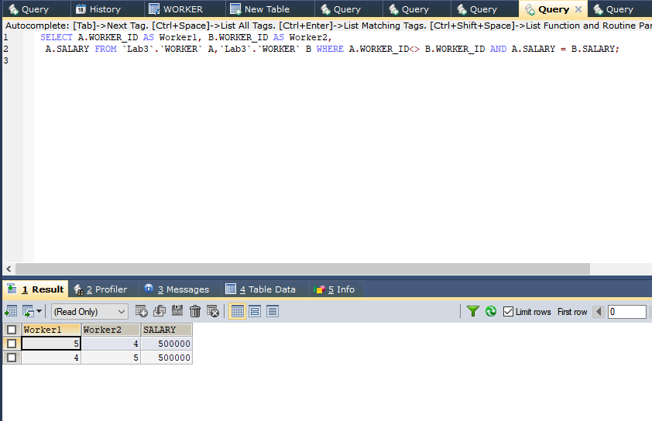
- Write An SQL Query To Show The Second Highest Salary From A Table.
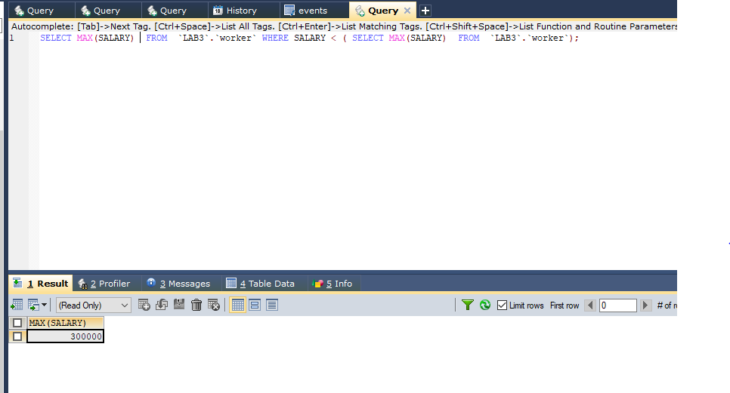

LAB TASK:
Execute OLTP queries for the following scenario:

An organization has a main data table that lists events. Each event has a series of fields including duration, reason code and status.
The OLTP system has a table of statuses with attributes status code and Name and there is a common field between the main table (status code), which allows the organization to print the status name rather than the code.
There are four statuses (ready, delay, spare and down) and there are a range of reasons associated with each status with reason codes. It is possible for the same reason code to exist in two statuses (e.g. delay maintenance and down maintenance).
For some reason, the source database has four tables of reasons (one for each status). Each of these has a field which links to the main reason code.
The organization wishes to do the following:
When the main table record status is ‘delay’, then retrieve the name in the ‘delay’ table which corresponds to the main table delay code. When the status is ‘down’, do the same thing but look up the name in the ‘down’ table.

SOLUTION:
Events:
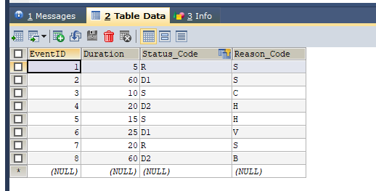

Status:

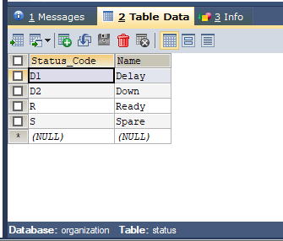
SpareReason:
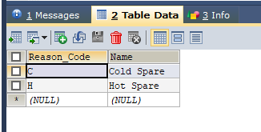

DelayReason:
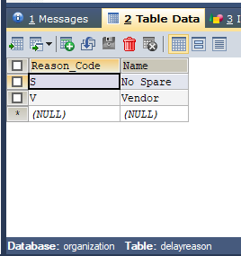

DownReason:

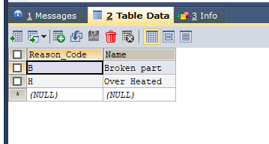

ReadyReason:

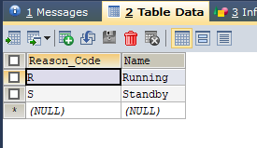

Selecting the Name of status instead the status_Code, using INNER JOIN Query

SELECT events.EventID, status.Name FROM
`organization`.`events` INNER JOIN `organization`.`status` ON events.Status_Code= status.Status_Code ORDER BY events.`EventID` ;
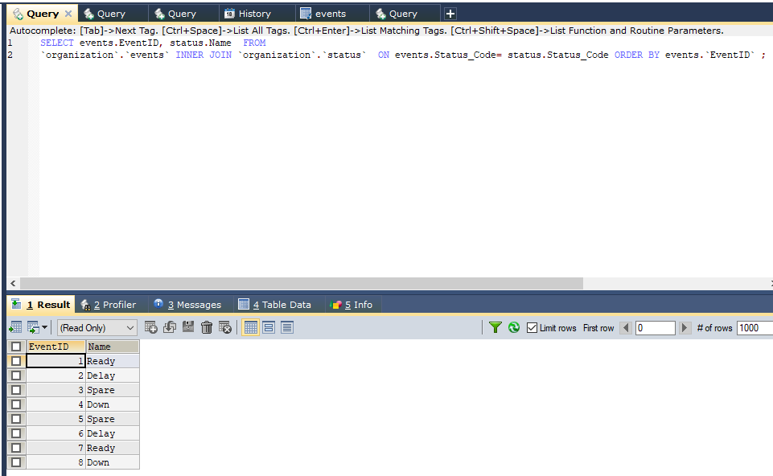

RESULT:
SELECT EventID, Duration, Status.Name AS Status_Name, Reason.Name AS Reason_Name FROM `organization`.`events` INNER JOIN `organization`.`status` ON Events.Status_Code = Status.Status_Code
INNER JOIN
(
SELECT 'R' AS Status_Code, Reason_Code, NAME
FROM ReadyReason
UNION
SELECT 'D1' AS Status_Code, Reason_Code, NAME
FROM DelayReason
UNION
SELECT 'S' AS Status_Code, Reason_Code, NAME
FROM SpareReason
UNION
SELECT 'D2' AS Status_Code, Reason_Code, NAME
FROM DownReason
) Reason
ON events.Status_Code = Reason.Status_Code AND
events.Reason_Code = Reason.Reason_Code ORDER BY EVENTID;

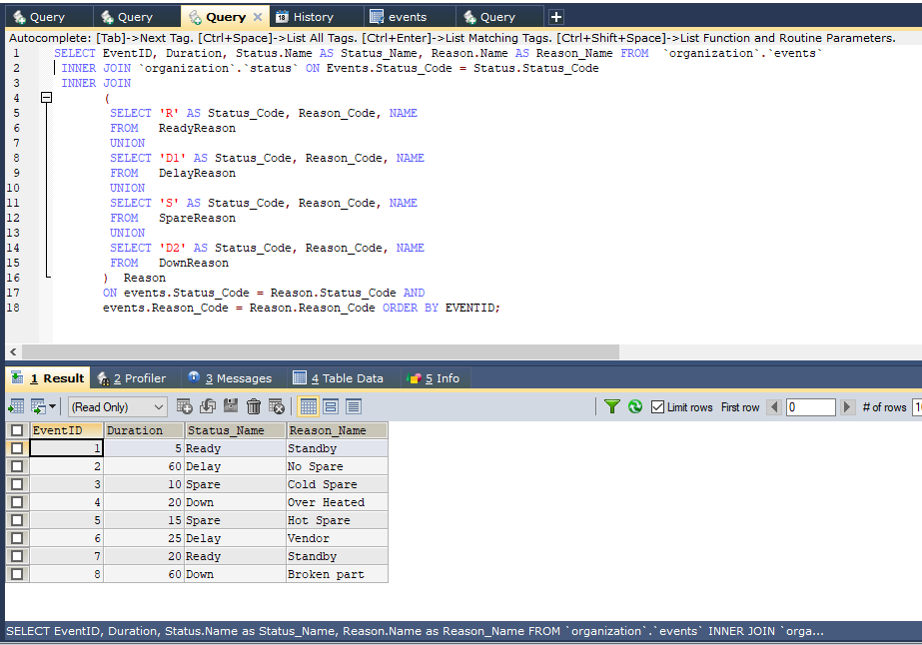

In the above query UNION is used to combine the data of multiple tables in a single table.

